MIE1624 COURSE PROJECT REPORT

A SOCIAL MEDIA SENTIMENT ANALYSIS ON THE WAR OF UKRAINE AGAINST RUSSIA

**Yan Cui** [mermaidyan.cui@mail.utoronto.ca](mailto:mermaidyan.cui@mail.utoronto.ca) — 1003922730

**Qishu Deng** [doris.deng@mail.utoronto.ca](mailto:doris.deng@mail.utoronto.ca) — 1009648160

**Zhixuan Mai** [zhixuan.mai@mail.utoronto.ca](mailto:zhixuan.mai@mail.utoronto.ca) — 1009777895

**Haoyu Shu** haoyu.shu[@mail.utoronto.ca](mailto:zhixuan.mai@mail.utoronto.ca) — 1003832427

**Luyuan Wang** luyuan.wang[@mail.utoronto.ca](mailto:zhixuan.mai@mail.utoronto.ca) — 1009227061

**Yu Xia** yumelissa.xia[@mail.utoronto.ca](mailto:zhixuan.mai@mail.utoronto.ca) — 1006422417

**Zhiqing Xu** [zhiqing.xu@mail.utoronto.ca](mailto:zhiqing.xu@mail.utoronto.ca) — 1000226249

# Introduction

The Russia-Ukraine conflict originated from political and territorial disputes between the two nations since 2014. The conflict escalated into a full-scale war on Feb 24, 2022, as Russian President Vladimir Putin mobilized the Russian army to invade Ukraine. The war is now the largest war in Europe since World War II, drawing global attention due to its implications for regional stability and international relations. It has become one of the most significant international crises of the 21st century and has lead to numerous discussions and debates among individuals. By collecting and analyzing the text data arising from these discussions, decision-makers can gain valuable insights into the diverse range of perspectives on the conflict and can further support effective decision-making on related issues.

Sentiment analysis is an important tool in the field of natural language processing (NLP). It is a technique used to identify the emotional tone and attitudes conveyed in various forms of human natural language, such as social media posts, news articles, or customer reviews. In this work, we leverage sentiment analysis to gain insights into public opinion regarding Russia’s unprovoked war against Ukraine by analyzing posts on social media. Such analysis can help to formulate recommendations to improve Ukraine’s image and gain more international support to defend its territory against Russian aggression.

In this work, We train multiple sentiment classification models for different purposes, including four non-neural network models (i.e., (1) logistic regression, (2) decision tree classifier, (3) Gaussian Na¨ıve Bayes and (4) XGBoost classifier) which serve as baselines, a 3-layer multilayer perceptron (MLP) classifier and a DistilBERT-based classifier based on the state-of-the-art NLP techniques. These classifiers are all trained using a dataset that contains over 550,000 tweets that have had their sentiments already analyzed and recorded as binary values 0 (negative) and 1 (positive). Apart from these binary sentiment classifiers, we also train a multilabel classification model that is capable of predicting the 8 primary bipolar emotions (joy versus sadness, anger versus fear, trust versus disgust, and surprise versus anticipation) from Robert Plutchik’s wheel of emotions. We utilize tweets from the SemEval2018 Task 1E-c emotion classification dataset to perform fine-tuning on the pretrained DistilBERT model. The dataset also contains binary labels 0 (negative) and 1 (positive) for optimism, pessimism and love. These labels are used to train 3 additional DistilBERT-based classifiers for predicting the existence of these emotions. Models trained by others are also used as comparisons to our models, including VADER (Valence Aware Dictionary and sentiment Reasoner) and a pre-trained DistilBERT-based threefold sentiment classification model (from [https://huggingface.co/Souvikcmsa/](https://huggingface.co/Souvikcmsa/SentimentAnalysisDistillBERT) [SentimentAnalysisDistillBERT](https://huggingface.co/Souvikcmsa/SentimentAnalysisDistillBERT)).

These machine learning-based sentiment analysis models are then implemented to identify sentiments and emo-

tions for scrapped comments and posts related to the Russian Ukraine War from Reddit, a social news aggregation and discussion platform. Sentiment labels predicted by different models are then compared in order to validate the performances of models that we have trained. We are able to demonstrate that the best non-neural network sentiment classifier we have trained is able to achieve comparable results to advanced deep learning-based models.

In order to identify factors/reasons/topics that drive sentiment, we utilize BERTopic to discover the most in- fluential topics. We analyze the sentiments of each comment under these hot topics and study the public opinion regarding the Russia-Ukraine War as well as other related international events. The analysis can be used to explore the most concerning topics and provide suggestions to the Ukrainian government and international NGOs.

Through a comprehensive analysis of the comments scrapped from Twitter and Reddit, we explore public sen- timent towards Russia and Ukraine, perceptions of President Zelensky, concerns about casualties, debates over re- sponsibility for the conflict, and dissatisfaction with NATO’s involvement. This analysis is intended to serve as a

© Y. Cui, Q. Deng, Z. Mai, H. Shu, L. Wang, Y. Xia & Z.X. .

consulting tool for the Ukrainian government and international NGOs to analyze how Ukraine is perceived inter- nationally and provide valuable recommendations to improve Ukraine’s international presence and image. All our models and results are available through <https://github.com/Zhiqing-Xu/SentimentAnalysis>.

# Methods and Results

## Part 1 - Non-Neural Network Sentiment Classifiers

Four different non-neural network classification models are trained, including (1) logistic regression, (2) decision tree classifier, (3) Gaussian Na¨ıve Bayes and (4) xgboost classifier. The dataset that we use to train the classifiers contains over 550,000 tweets that have had their sentiments already analyzed and recorded as binary values 0 (negative) and 1 (positive). We use two different vectorizers to process the text data and perform feature selection before training the model. Grid search are also conducted based on 5-fold cross-validation in order to select the best hyperparameters of each model. The best-performed model is able to achieve a 0.95+ accuracy and F1-score on the test dataset.

* + 1. Part 1 - Data Cleaning and Preprocessing

The dataset we have used to train the sentiment classification models contains around 550,000 tweets that have been analyzed and recorded as binary values 0 and 1, representing negative and positive sentiments, respectively. The dataset has been collected directly from the web and the text data may contain html tags, hashtags and user tags which are mostly meaningless. We remove all these tags, URLs, “#” in Hashtags, Retweet texts before we identify the language of each comment and drop these non-English texts. Meaningless comments (e.g., very short sentences or advertisements) can be identified through checking duplicates in the dataset and are removed as well. All duplicated instances are also removed before Unicode characters are filtered out. The processed dataset contains 440,900 instances.

* + 1. Part 1 - Vectorizers and Data Splitting

We use two feature engineering techniques, term frequency-inverse document frequency (hereinafter referred to as TF-IDF) and Bag of Words (or BoW), both commonly used for tasks such as text classification, information retrieval, and topic modeling. TF-IDF is a statistical measure that reflects the importance of a word in a document corpus. Bag of Words is a simpler approach that counts the frequency of each word in a text. Stop words, punctuations and numbers are removed from the text data before being vectorized using either TF-IDF or Bag of Words. The vectorized dataset (numerical representations of text data together with their corresponding sentiment labels) is split into a training set and a test set with a ratio of 8:2.

In terms of model training and evaluation process, we trained and evaluated five classification algorithms on the dataset. The algorithms we used are Logistic Regression, Naive Bayes, Decision Tree, XGBoost and MultiLayerPer- ceptron Predictor models. For each algorithm, we used the features extracted from either TF-IDF or Bag of Words as input and the sentiment value as the target variable.

* + 1. Part 1 - Feature Selection

Chi-squared feature selection is a statistical method used to select the most important features in a dataset for classification tasks. It measures the independence between a feature and a target variable by comparing the observed frequency of their co-occurrence in the data with the expected frequency under the assumption of independence. In this work, Chi-squared feature selection is implemented to select the 1000 most important vectorized features of the input texts (for both TF-IDF-vectorized data and BoW-vectorized data). We evaluate the performance of prediction using different numbers of top features (including 500, 1000, and 2000) and it has been demonstrated that using 1000 features provides the optimal performance.

* + 1. Part 1 - Cross Validation and Hyperparameter Tuning

To determine the best hyperparameters for each model, a grid search is performed using 5-fold cross-validation. Models with their best hyperparameters are then evaluated by their performances on the test set and results are reported in the next section.

* + 1. Part 1 - Model Performance on the Test Set

The predictive performances of models we have trained are summarized in Table 1 above. We report the accuracy of each model’s prediction on the test set. Among the non-neural network models, XGBoost and Logistic Regression

Table 1: Predictive performances of four different Non-neural network sentiment classifiers on the test set as well as performances of a 3-layer MLP classifier

Non-Neural Network Classification Models

|  |  |  |  |  |  |
| --- | --- | --- | --- | --- | --- |
|  | Logistic Regression | Naive Bayes | Decision Tree | XGBoost | MLP |
| Vectorizer  TF-IDF | 0.9513 | 0.9072 | 0.7870 | 0.7552 | 0.9660 |
| Bag of Words | 0.9513 | 0.9378 | 0.7724 | 0.9512 | 0.9666 |

has achieved relatively better performance with an accuracy of 0.9512 for Bag of Words (see Figure 1 and 2) and 0.9513 for both TF-IDF and Bag of Words respectively. We also observe that MultiLayer Perceptron (MLP) model outperforms all other algorithms with an accuracy of above 0.96 for both TF-IDF and Bag of Words. A DistilBERT- based classifer has also been trained and has achieved an accuracy of above 0.99 but is NOT listed and compared here with these small models since it is based on large pretrained language models and it has utilized the most advanced NLP techniques. All details including the F1-score, precision, recall, and ROC-AUC for each model we have trained are included in the “Part 1.ipynb” file in the folder we submit. We have plotted ROC curve, precision-recall curve and confusion matrix for all of the models we have trained and the figures are included in “Part1 Figures” folder in the folder we submit.

To summarize, we trained and evaluated five classification models on a dataset that contains 550k tweets with binary labels for sentiment prediction. We used two feature engineering techniques, TF-IDF and Bag of Words, to preprocess the data and convert the text into a numerical representation. We then used an 80-20 train-test split for training and evaluation and performed 5-fold cross-validation for hyperparameter tuning and model evaluation. The results indicate that the multi-layer perceptron classifier could be a more effective approach for sentiment analysis tasks; however, the selection of the most appropriate algorithm may ultimately depend on the specific application and dataset to be studied.

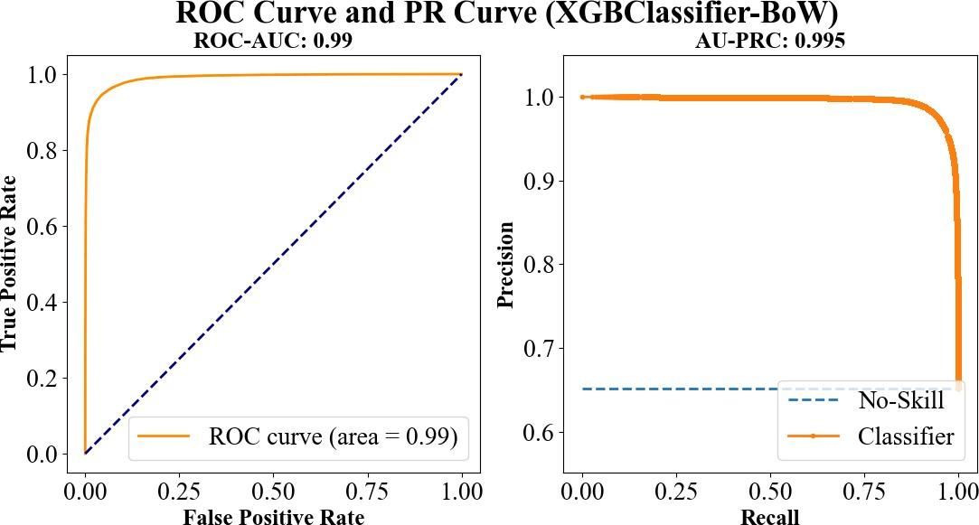

Figure 1: Receiver Operating Characteristic (ROC) curve and Precision-Recall (PR) curve plotted for XGBClassifier using Bag of Words.

## Part 2 - Sentiment Analysis on Comments Related to the Russian Ukraine War

In this section, two datasets that contain a total number of around 270,000 scrapped comments and posts related to the Russian Ukraine War from Reddit are studied. Apart from the best-performed binary classifiers that has been trained on the 550,000 tweets data in Part 1 (including four non-neural network models, a 3-layer MLP classifier, and a DistilBERT-based classifier), we implement two more threefold sentiment prediction models trained by other

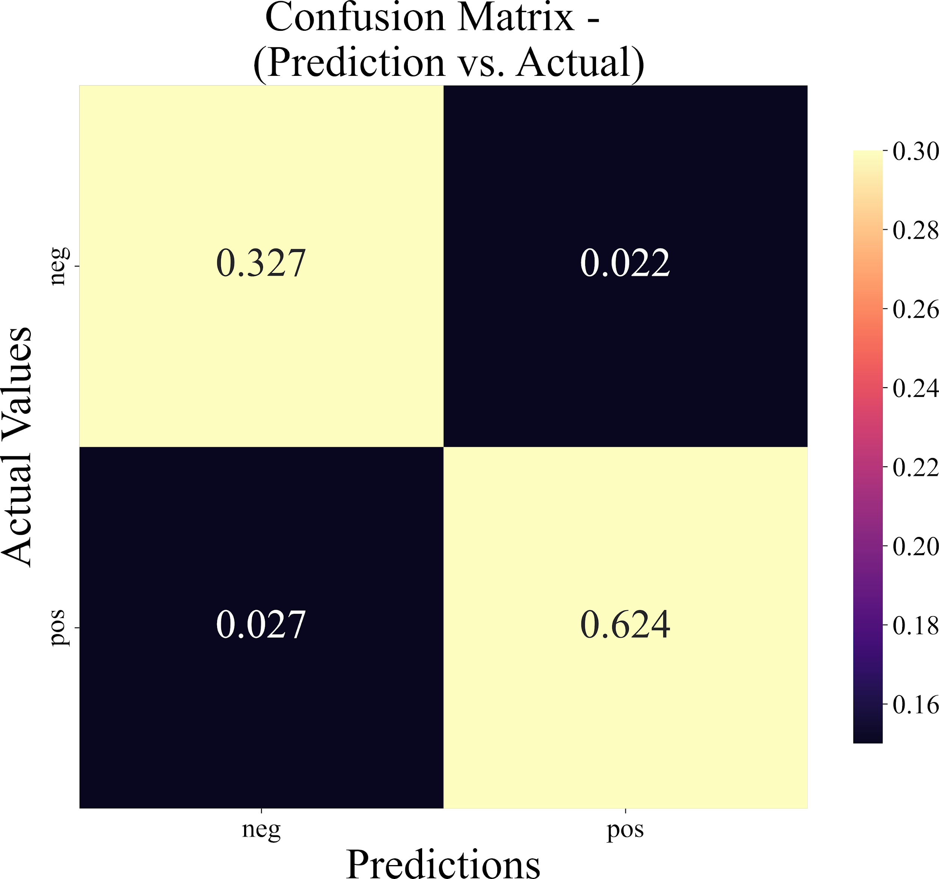

Figure 2: Confusion matrix for binary classification: visualizing XGBClassifier (using Bag of Words) performance on test set.

researchers to study the Reddit comments. Based on comparing the sentiment labels generated by different models we choose the best sentiment analysis model for further studies.

* + 1. Part 2 - Data Cleaning and Preprocessing

We use the exact same data cleaning and preprocessing pipeline as the one for the 550k tweets dataset. We process the 270k Reddit dataset in the following order, (1) remove all tags (i.e., user tags, hashtags HTML tags), (2) identify and remove non-English text, (3) remove meaningless comments (mostly short responses and advertisements) and duplicates and (4) remove all Unicode characters. The processed dataset contains around 190,000 instances.

* + 1. Part 2 - Valence Aware Dictionary and sEntiment Reasoner or VADER

VADER (Valence Aware Dictionary and sentiment Reasoner) is a lexicon and rule-based sentiment analysis tool designed to identify and quantify the sentiment (positive, negative, or neutral) in text. It uses a combination of sentiment lexicons and grammatical rules to analyze the sentiment of a given text and provide a sentiment score based on the intensity of each sentiment detected. It is a popular choice for sentiment analysis tasks in natural language processing due to its accuracy, speed, and ease of use. VADER produces a compound score for input text by summing the normalized positive, negative, and neutral sentiment scores, which enables the classification of text input into positive, negative, or neutral categories. We implement VADER (using Natural Language Toolkit or “nltk” library in Python) on the processed dataset and generate labels for all the comments. Figure 3 shows the counts of positive, negative and neutral labels (generated by VADER) in the cleaned dataset of Reddit comments on the Russian-Ukraine War.

* + 1. Part 2 - DistilBERT-based Threefold Sentiment Classifier

DistilBERT (Sanh et al., 2019) is a distilled (small, fast, cheap and light) version of the larger BERT (Bidirectional Encoder Representations from Transformers) model, which has been pre-trained on a large corpus of text data to

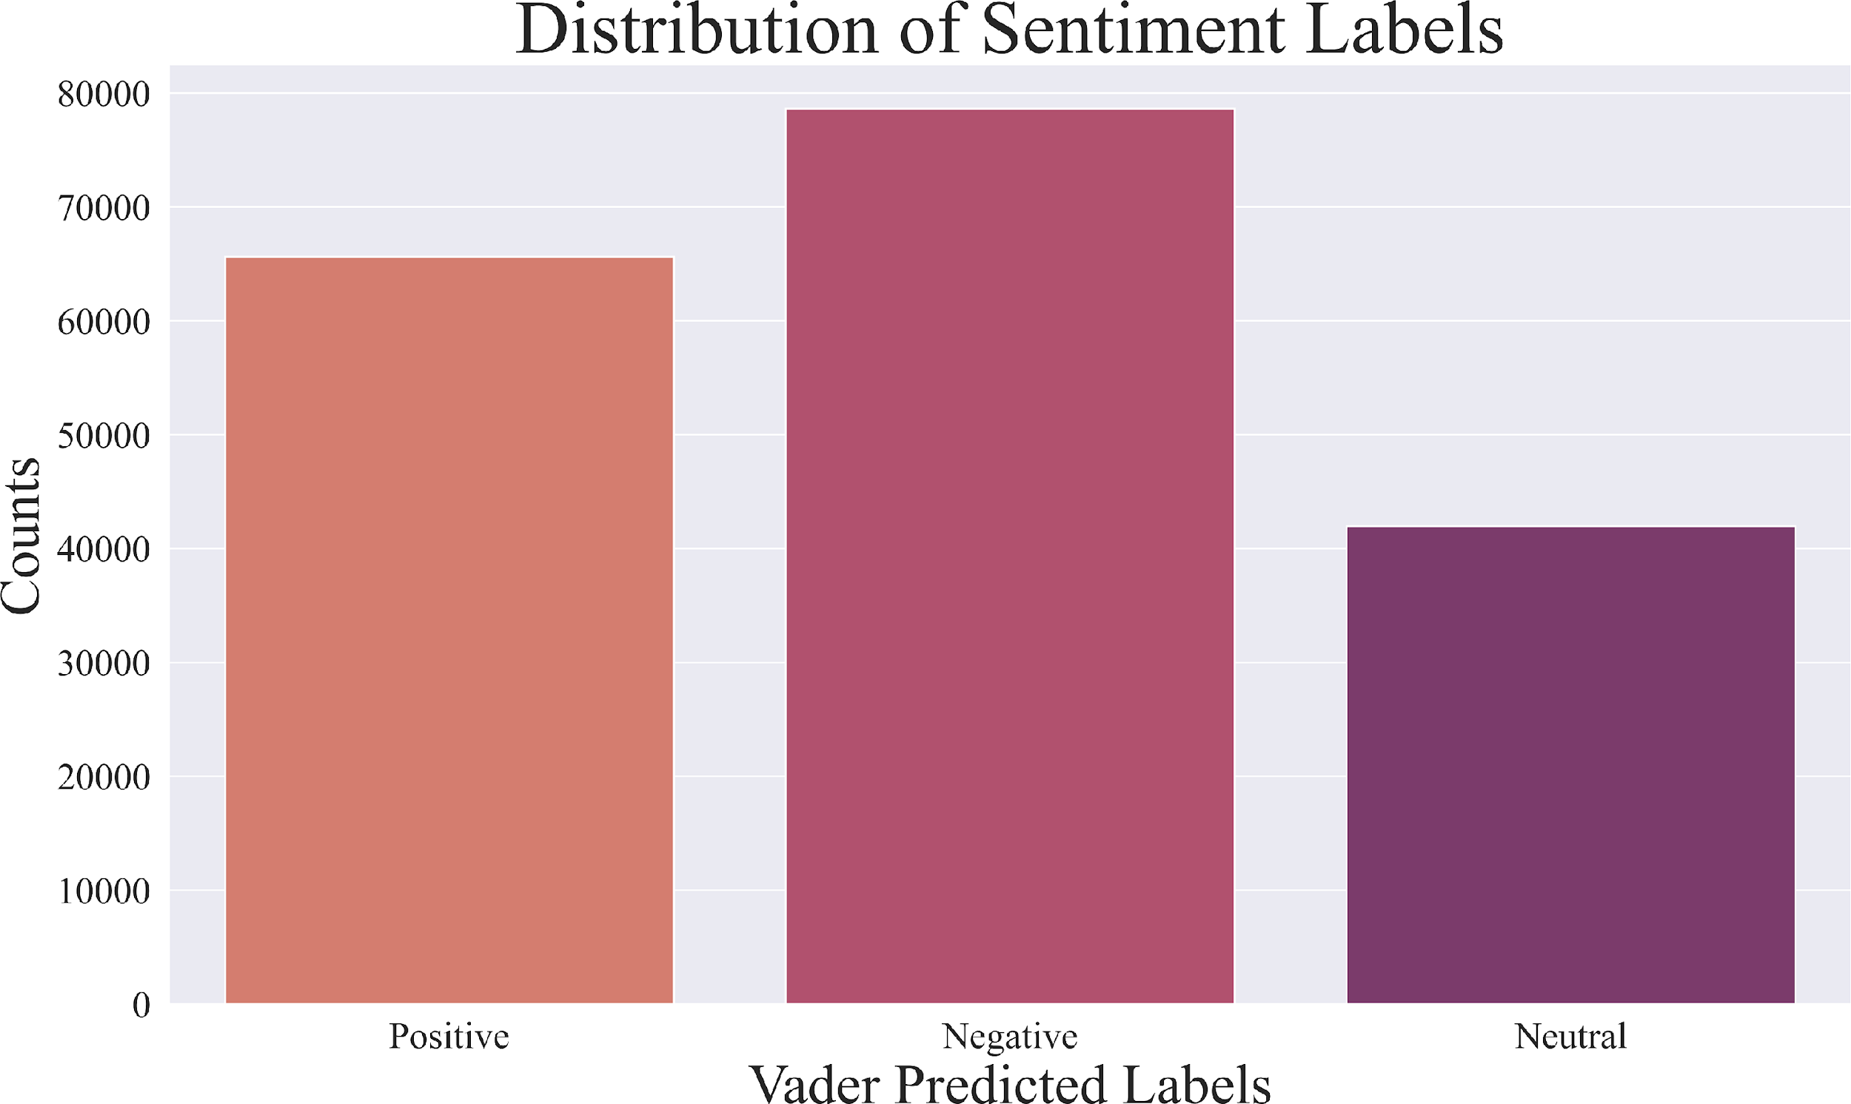

Figure 3: Distributions of sentiment labels predicted by VADER

learn contextualized word embeddings. The pre-trained DistilBERT model can be fine-tuned on a specific task, such as sentiment analysis or text classification, by adding a classification layer on top of the pre-trained model. The advantage of using a fine-tuned DistilBERT-based classifier is that it can achieve state-of-the-art performance on many NLP tasks, while requiring less computational resources and training time compared to the larger BERT model (e.g., RoBERTa (Liu et al., 2019)). We implement a fine-tuned DistilBERT-based classifier trained by others (model is available on Hugginface at, <https://huggingface.co/Souvikcmsa/SentimentAnalysisDistillBERT> ) on the pro- cessed dataset and generate labels for all the comments. Figure 4 shows a comparison of sentiment labels generated by VADER and the DistilBERT-based classifier trained by others. We observe over 60% of the sentiment labels predicted by DistilBERT-based classifier align with the labels produced by VADER. Although the two models generate different labels for some relatively more “neutral-ish” comments, the percentage of opposite sentiments predicted (positive vs. negative) is very low (3.4%). This result confirms the reliability of both VADER and DistilBERT-based sentiment classifiers.

* + 1. Part 2 - Classifiers Trained in Part 1

The best-performed binary classifiers trained in Part 1 are also used to generate binary sentiment labels (positive vs. negative) for the dataset. The predicted labels are also compared with VADER’s prediction since VADER is also capable of generating binary labels through adjusting a “compound score threshold”. It is believed that the agreement with VADER’s sentiment prediction (which is quite reliable) demonstrates the predictive performance of the sentiment classifier. Point-Biserial correlation coefficient is used to estimate the agreement between VADER and these classifiers. Among the top models in Part 1 (logistic regression model, XGBoost (with BoW) and MLP classifier), XGBoost achieved the best performance with a 0.30 Point-Biserial correlation coefficient (0.01 for logistic regression and 0.08 for MLP classifier). Moreover, XGBoost’s predictions agree with the sentiment labels identified by VADER in over 59% of cases, which is comparable to the distilBERT-based classifier that has achieved a 60% alignment.

The logistic regression model and MLP classifier exhibit poor predictive performance on the new dataset (which is dissimilar to the training set), primarily due to the issue of overfitting. The high sensitivity of logistic regression to outliers, coupled with its assumption of linearity, results in even poorer predictions compared to the MLP classifier. In contrast, XGBoost is able to measure the importance of each feature in the model and include only the most relevant features, thereby avoiding overfitting. Additionally, it randomly subsamples the training dataset during each boosting iteration, which improves generalization and further prevents overfitting. All details including the confusion matrix as well as values of Point-Biserial correlation coefficient for comparing the models we have trained are included in the “Part 2.ipynb” file in the folder we submit. The figures are all included in “Part2 Figures” folder in the folder we submit.

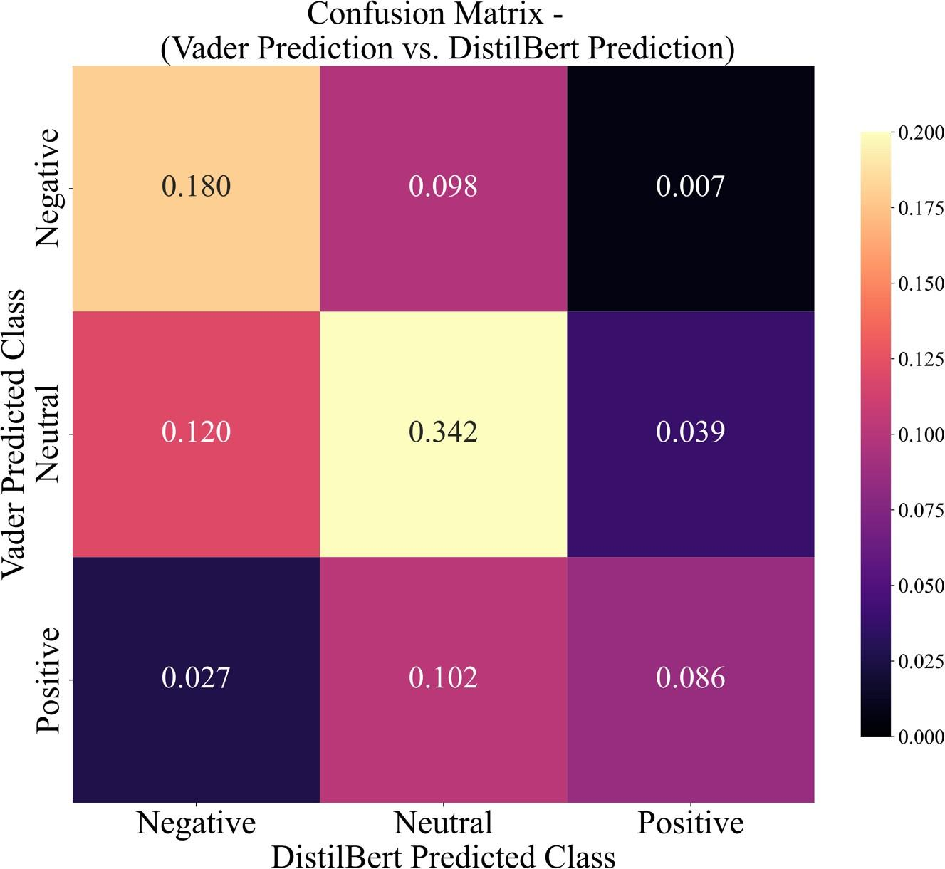

Figure 4: Confusion matrix for comparing sentiment labels generated by VADER and DistilBERT- based classifier

* + 1. Part 2 - Multi-label Emotions classification

While the above binary or threefold sentiment classifiers are limited to generating positive, negative, and neutral labels, human emotions are far more complex. In order to capture the full range of human emotions, we train a multi-label model that is capable of predicting the eight primary bipolar emotions (joy versus sadness, anger versus fear, trust versus disgust, and surprise versus anticipation) defined in Plutchik’s Wheel of Emotions. While NVIDIA’s previous work (Kant et al., 2018) on predicting emotions using a general Transformer architecture-based model has shown some success, BERT (Bidirectional Encoder Representations from Transformers) is a more advanced approach that is capable of capturing bidirectional context and has a more sophisticated pre-training methodology. Its pre- training on large amounts of text data also allows it to learn a broad range of linguistic features, this makes it outperform previous state-of-the-art models on a range of benchmarks and become a popular choice for fine-tuning on specific NLP tasks. In this work, we train multiple DistilBERT-based classifiers for multilabel classifications that allow identification of the 8 primary bipolar emotions from Robert Plutchik’s wheel of emotions. We utilize the same dataset used by Kant et al. (2018), tweets from the SemEval2018 Task 1E-c emotion classification dataset (Mohammad et al., 2018) to perform fine-tuning on the pretrained DistilBERT model. The dataset also contains three more labels of optimism, pessimism and love. Therefore, a total of 11 DistilBERT-based classifiers are trained to identify complex human emotions.

## Part 3 - Topic Analysis and Identification

In order to identify reasons or factors that drive sentiment, we perform topic analysis on the scrapped Reddit dataset. A traditional approach of topic analysis is LDA (Latent Dirichlet Allocation) which relies on a probabilistic model to assign topic distributions to each document. However, BERTopic is considered to be a more advanced topic modeling technique than LDA for two main reasons. Firstly, BERTopic utilizes the power of BERT that has been pre-trained on massive amounts of text data and has shown superior performance in a wide range of NLP tasks. This allows BERTopic to identify topics with greater accuracy and efficiency compared to LDA. Secondly, BERTopic

uses a clustering approach to group similar documents, making it less sensitive to outliers and resulting in more accurate and robust topic modeling results compared to LDA. Furthermore, BERTopic transforms text data into vector representations using BERT and clusters them into topics through hierarchical clustering which allows it to handle large volumes of text data and identify meaningful and interpretable topics. Therefore, it is considered to be the best option we have for topic identification.

The topics identified by BERTopic are further formed into clusters based on Hierarchical Clustering ( shown in Figure 5 ). Details of clustered topics can be found in Appendix B (See Table A1 and Figure A2 for topic clusters and a heatmap visualizing the inter-correlation (similarity) of hot topics).

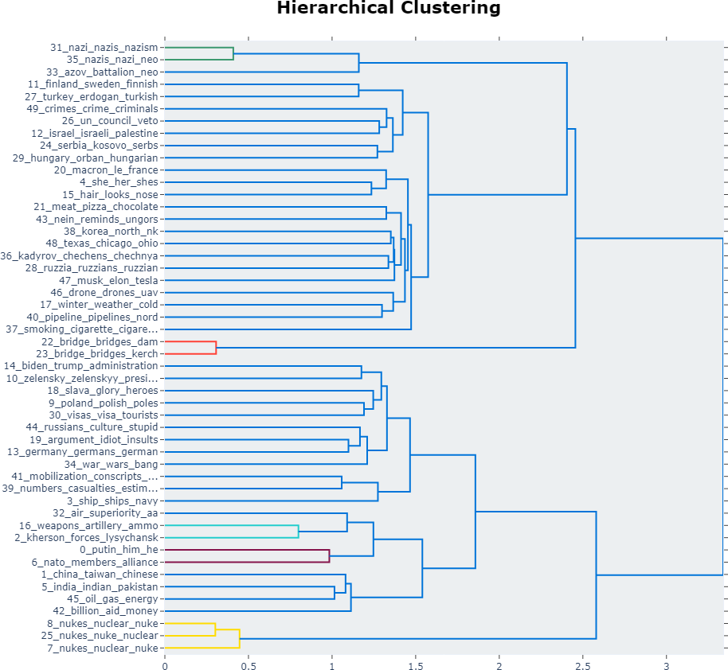

Figure 5: Plot of hierarchical clustering of topics identified by BERTopic (Only top 50 hot topics are shown)

For each topic cluster identified, sentiment analysis is performed to study the public opinion regarding the Russia-Ukraine War as well as other related international events. It is observed that there is a strong correlation between the topics discussed in comments and the corresponding sentiment and emotions expressed in those comments (with some examples shown in the below sections).

* + 1. Part 3 - Topic Analysis #1 - Nuclear War VS. Pray for Ukraine

Figure 6 shows a comparison of emotions detected in comments under two distinctive topics. “Anger” and “disgust” emotions are above 20% in the “Pray for Ukraine” topic mainly because some people are expressing negative feelings about the war but NOT about Ukraine or peace. The prevalence of the ”love” and ”optimism” emotions suggests that these sentiments drive a majority of individuals to believe victory belongs to Ukraine. In contrast, “anger” and “disgust” emotions are detected in almost 80% of the comments related to the ”Nuclear War” topic.

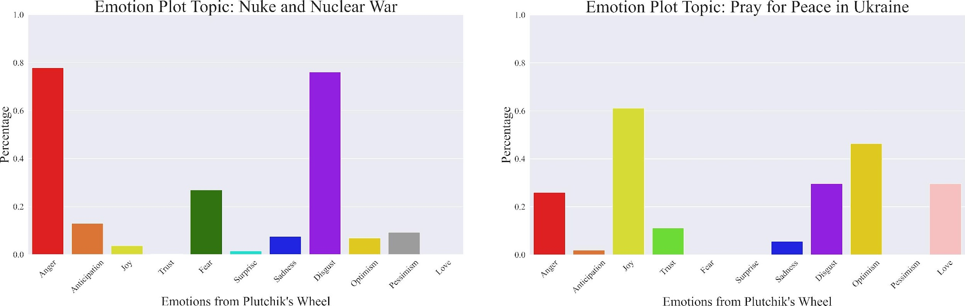

Figure 6: Emotions detected in comments under two distinctive topics; Nuclear War VS. Pray for Ukraine

The Russian-Ukrainian conflict has heightened international concerns about nuclear war, as evidenced by the prevalence of negative sentiment towards the topic in both the sentiment analysis and emotions detection models. Ukraine, as a former nuclear power, has actively worked towards nuclear disarmament and non-proliferation, but its conflict with Russia has raised concerns about the security of its nuclear facilities and the potential for proliferation. The annexation of Crimea by Russia has further complicated the situation, as it is home to several Ukrainian nuclear facilities. While both Ukraine and Russia have denied any intention to use nuclear weapons, the possibility of accidental or intentional nuclear escalation remains a concern that requires international efforts to reduce tensions and prevent conflict.

* + 1. Part 3 - Topic Analysis #2 - Countries and NATO

Another important theme reflected in the data set is the attitude and measures taken by neighboring countries towards the conflict. These neighbors are primarily divided between the camp of pro-Ukrainian and pro-Russian states, and this division between the two camps highlights the complex geopolitical dynamics of the region and the challenges of maintaining stability and security in the face of conflicting interests and ideologies. The attitudes and measures taken by neighboring countries towards the conflict have had a significant impact on its outcome and will continue to have a significant impact on the region in the years to come.

On the one hand, the measures taken by neutral countries like Finland and Sweden as a result of the Russia-Ukraine conflict are of great interest. In general, the behavior of these countries indicates their pro-Ukrainian attitudes, but in terms of sentiment analysis, the proportion of negative statements is still slightly larger than positive statements in the results (See Figure A12). This is most likely because NATO readily accepted formerly neutral countries such as Finland and Sweden to join NATO, but repeatedly delayed Ukraine’s accession, which to some extent reflects people’s negative attitudes toward these conflict-related countries and NATO’s inaction.(See Figure A11)

Finland and Sweden, as representatives of the pro-Ukrainian national camp, provide military and humanitarian assistance to Ukraine, which reflects the international community’s view of Ukraine as a victim of Russian aggression and a country that deserves the support and assistance of the international community. As neutral countries, Finland and Sweden’s statements of support for Ukraine can be seen as particularly significant. These countries are not members of NATO or the European Union and are not directly involved in the conflict. Their willingness to offer military assistance to Ukraine and condemn Russia’s actions demonstrates that the conflict has broader implications for international security and stability beyond the immediate region. Furthermore, the opposition of Finland and Sweden to Russian sanctions can be seen as an expression of concern over Russian aggression and the potential impact of sanctions on the region. These countries may believe that sanctions are unlikely to change Russian behavior and that diplomatic efforts are a more effective way to address the conflict.

The humanitarian assistance offered by Finland and Sweden to Ukraine also reflects the broader international concern for the humanitarian situation in the country. The conflict has displaced millions of people and created a humanitarian crisis, and many countries have provided aid and support to alleviate the suffering of those affected.

However, the conflict in Ukraine is not simply a matter of humanitarian concern. It is also viewed through a geopolitical lens, with many countries aligning themselves with either Russia or the West. The involvement of

other countries in the conflict are often seen as a way to gain geopolitical advantage or protect their own interests. The behavior of Finland and Sweden, as neutral countries, can be seen as an attempt to rise above these geopolitical considerations and demonstrate a commitment to international law and norms. And as we mentioned earlier, people’s views on these countries are actually mixed, which also shows that one measure that Ukraine can take at present is to continue to exert pressure on NATO and seek the protection and substantive attention of neighboring countries.

Overall, Finland and Sweden’s behavior reflects the international community’s perception of Ukraine as a victim of Russian aggression and a country deserving of support and assistance. The conflict in Ukraine is viewed through both humanitarian and geopolitical lenses, with many countries aligning themselves with either Russia or the West. The behavior of neutral countries like Finland and Sweden can be seen as an attempt to take a principled stance and demonstrate a commitment to international norms and security. This shows that Ukraine is perceived to be the victim globally and Russia’s behavior has threatened the neighboring country of Ukraine as well.

On the other hand, the moves of countries that have shown pro-Russian actions in the Russia-Ukraine conflict are a major focus of attention. In the expert group's sentiment survey, public opinion in the pro-Russian camp countries is predominantly negative, reflecting their dissatisfaction with Russia for provoking the conflict and their belief that Ukraine, as a victim, should receive more support from other countries and groups. In Figure A12, it can be seen that people's negative sentiment toward Belarus and Hungary, two pro-Russian countries, far outweighs the positive.

Belarus, a country with which Russia is a long-standing alliance, is a representative of pro-Russia, which has traditionally been politically and economically aligned with Russia, and the two countries have a mutual defense agreement. Belarus is a member of the Eurasian Economic Union (EEU) and the Collective Security Treaty Organization (CSTO), both of which are dominated by Russia. As a country located just under 200 kilometers in a straight line from Ukraine's capital, Kiev, Belarus is already strategically positioned to hold Ukraine's substantial military forces at bay to a large extent. Belarus, however, has allowed Russia to maneuver on its territory and airspace throughout this conflict, and early in the war, Russian forces launched attacks on northern Ukraine from Belarusian territory with the help of Belarusian military bases.

In addition, Belarus has expressed doubts about the legitimacy of the Ukrainian government and accused it of being under the control of Western powers. Belarus criticizes Ukraine's military actions in the conflict, especially the use of heavy weapons, and calls for a peaceful negotiated settlement of the conflict.

The negative sentiment toward Belarus is mainly due to its perceived support for Russia and perceived indifference toward Ukraine and lack of action in response to the conflict. In addition, Belarus has been criticized for its poor record on human rights and democracy. It has been noted that the authoritarian government led by Belarusian President Lukashenko shares some similarities with the government led by Russian President Vladimir Putin, both of which have been accused of suppressing political opposition and restricting civil liberties.

Hungary, another pro-Russian country, tried to prevent Ukraine from joining NATO during the Russia-Ukraine conflict. Hungary's actions are rooted in Hungary's long-standing opposition to Ukraine's language and education policies, which it views as discriminatory against its minority population in Ukraine. Hungary is particularly critical of Ukraine's 2017 education law, which restricts the use of minority languages in education beyond elementary school.

Furthermore, Hungary believes that it is not in the country's interest to sever Hungarian-Russian relations and that sanctions against Russia would destroy Hungary; therefore, the Hungarian government strongly opposes the sanctions and will continue to maintain economic relations with Russia. This move can be seen as a protection of Hungary's national interests, but many in the international community view Hungary's behavior toward Ukraine negatively. It is seen as an attempt to undermine the sovereignty and territorial integrity of Ukraine and as a violation of international law and norms. Hungary's language policy towards Ukraine is also seen as an attempt to increase ethnic tensions and destabilize the region.

In conclusion, the actions of both countries are seen as undermining the sovereignty and territorial integrity of Ukraine, and their positions and diplomatic efforts on the issue have exacerbated ongoing tensions between the EU, Ukraine and Russia.

# Conclusions and Recommendations (Part 4)

Based on the analysis of tweets and articles, we suggest the following recommendations for the Ukrainian government to stir up public sentiment positively and gather support:

1. Enhance economic development: This is suggested by the topic related to the economy, which shows people’s concern regarding the global economic downfall caused by the war. Thus, economic development is essential for im- proving the standard of living and attracting foreign investment. The Ukrainian government should focus on creating a more favorable business environment, promoting entrepreneurship, and investing in infrastructure. International NGOs can support these efforts by providing technical assistance, training, and funding.
2. Strengthen cultural diplomacy: The dataset analysis shows that the public is aware of and is concerned with Ukraine’s culture during the war. The Ukraine government should emphasize how Russia is attempting to destroy its culture. Ukraine has a rich cultural heritage that can be leveraged to improve its international presence. The Ukrainian government and international NGOs should focus on promoting Ukrainian culture through cultural exchange programs, festivals, and exhibitions. This can help to build cultural bridges with other countries and improve Ukraine’s image as a vibrant and dynamic country.
3. Focus on humanitarian aid and support the victims of the conflict: As mentioned in the previous analysis, countries that make donations to Ukraine tend to increase positive sentiment. Thus, the government of Ukraine can demonstrate its commitment to helping those affected by the war by providing support to refugees, families of soldiers, and other vulnerable populations. This can include providing financial assistance, medical care, and psychological support. Ukraine can also ask internal NGOs for support. This will enhance the public image of both Ukraine and international NGOs because it shows their strong standpoint toward Russia’s inhumane behavior and their best effort to improve the situation.
4. Highlight the resilience and bravery of the Ukrainian people: Despite the difficult circumstances, Ukrainians have shown remarkable strength and determination in the face of adversity. The government can share stories of everyday people who have shown extraordinary courage and resilience in the face of war, both within Ukraine and internationally. Journalists should report more on the events of Ukrainian war heroes to inspire the military, influence people around the world to pay attention to the war, gain more international support, and make it harder for Russia to take action in Ukraine.
5. Negotiations: Promote peace, continue negotiating with Russia, reach consensus to end the war as soon as possible, and provide more international aid to disaster victims.
6. Voicing up on online resources like Reddit and Twitter: By sharing information and personal perspectives, individuals can help raise awareness about the urgent need for international support. In particular, it is essential for European countries to step up and contribute more help to Ukraine. As a neighboring country, Ukraine is a key strategic partner for Europe. It is also a democracy that has been fighting for its independence and sovereignty against Russian aggression for years. Despite this, the international response to the crisis in Ukraine has been insufficient, leaving the country vulnerable and in need of more support. One way that individuals can advocate for more help for Ukraine is by highlighting the human impact of the conflict. By sharing stories of the lives lost and the hardships faced by those living in conflict-affected areas, people can help generate empathy and support for the Ukrainian people. It is important to remember that this conflict has resulted in thousands of deaths and millions of people being displaced from their homes. Another way to advocate for more support for Ukraine is by emphasizing the broader geopolitical implications of the crisis. The conflict in Ukraine has implications not only for the region but also for the broader international order. By supporting Ukraine, European countries can help uphold the principles of democracy and sovereignty that are essential for the stability of the region and the world. Ultimately, it is crucial that European countries step up and provide more concrete help to Ukraine. This can include economic assistance, military aid, and political support. By working together, European countries can help bring an end to the conflict and support Ukraine's ongoing efforts to build a democratic, stable, and prosperous society. In conclusion, voicing up on online resources like Reddit and Twitter can be a powerful way to advocate for more help for Ukraine. By sharing personal stories, highlighting the human impact of the conflict, and emphasizing the broader geopolitical implications, individuals can help generate support for Ukraine and encourage European countries to provide more concrete assistance. Together, we can help Ukraine build a better future and uphold the principles of democracy and sovereignty that are essential for a peaceful and prosperous world.

# References

Neel Kant, Raul Puri, Nikolai Yakovenko, and Bryan Catanzaro. Practical text classification with large pre-trained language models. *CoRR*, abs/1812.01207, 2018. URL <http://arxiv.org/abs/1812.01207>.

Yinhan Liu, Myle Ott, Naman Goyal, Jingfei Du, Mandar Joshi, Danqi Chen, Omer Levy, Mike Lewis, Luke Zettle- moyer, and Veselin Stoyanov. Roberta: A robustly optimized BERT pretraining approach. *CoRR*, abs/1907.11692, 2019. URL <http://arxiv.org/abs/1907.11692>.

Saif M. Mohammad, Felipe Bravo-Marquez, Mohammad Salameh, and Svetlana Kiritchenko. Semeval-2018 Task 1: Affect in tweets. In *Proceedings of International Workshop on Semantic Evaluation (SemEval-2018)*, New Orleans, LA, USA, 2018.

Victor Sanh, Lysandre Debut, Julien Chaumond, and Thomas Wolf. Distilbert, a distilled version of BERT: smaller, faster, cheaper and lighter. *CoRR*, abs/1910.01108, 2019. URL <http://arxiv.org/abs/1910.01108>.

# . Appendix A - Plutchik’s Wheel of Emotions

Plutchik’s Wheel of Emotions is a psycho-evolutionary theory that categorizes eight primary bipolar emotions - joy/sadness, anger/fear, trust/disgust, and surprise/anticipation - as well as various mixtures of these emotions. The wheel illustrates the relationships between these emotions, and is widely used in psychology and other fields to understand and analyze human emotions.

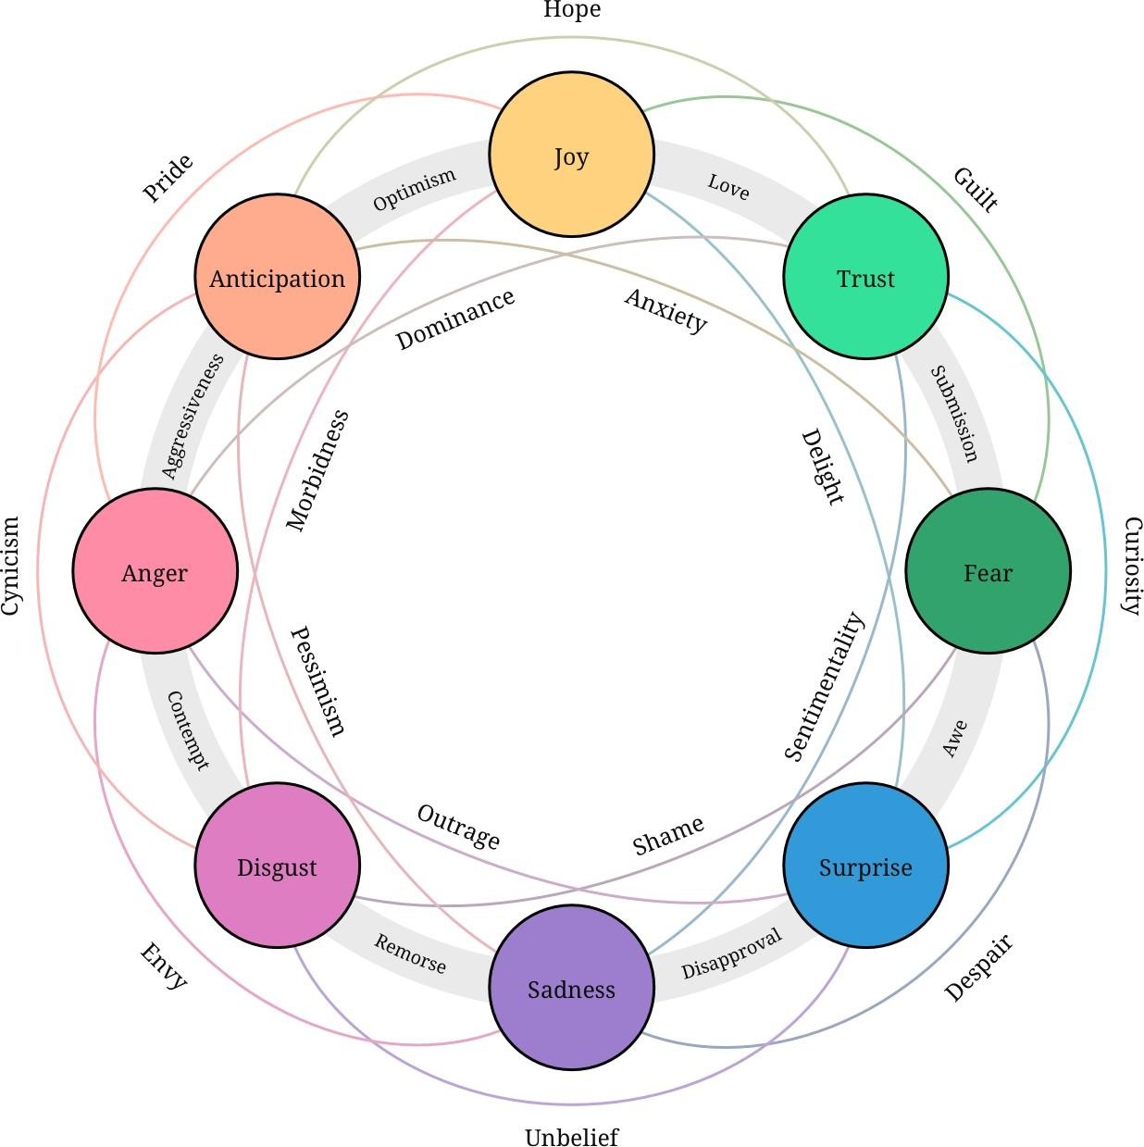

Figure A1: Plutchik’s Wheel of Emotions. A DistilBERT-based Classifier is trained for each of the eight primary emotions including, (1) Anger, (2) Anticipation, (3) Joy, (4) Trust, (5)

Fear, (6) Surprise, (7) Sadness, (8) Disgust.

# . Appendix - B

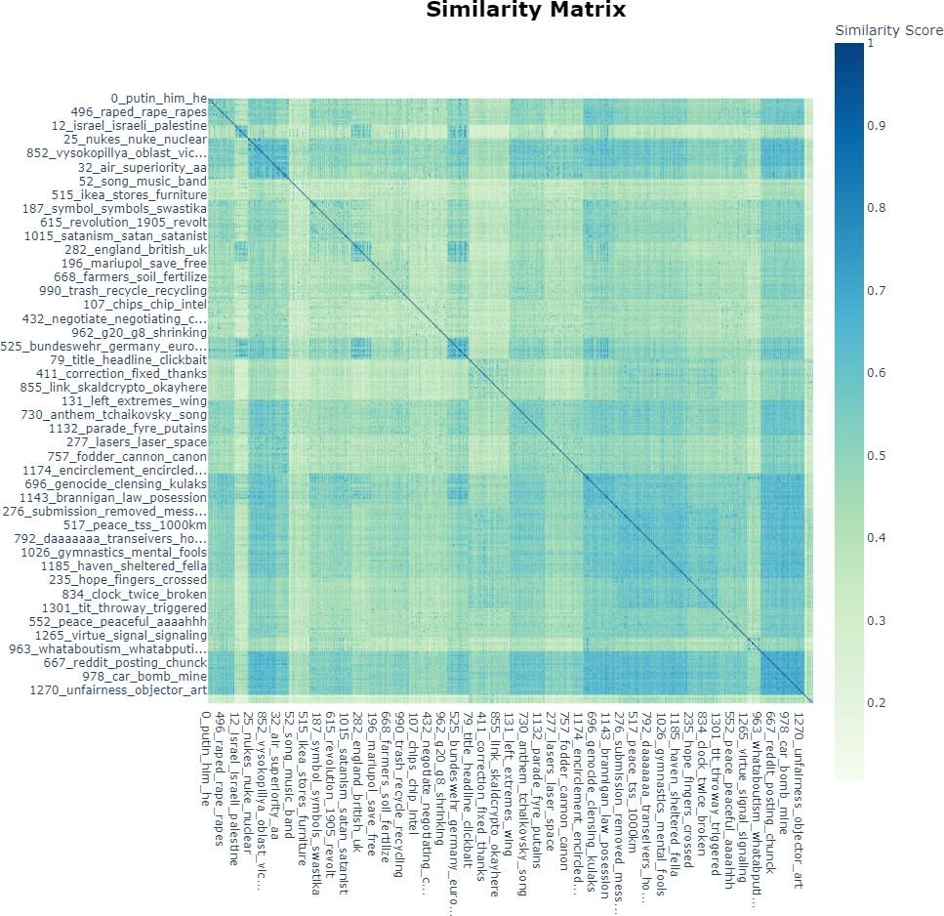

Figure A2: Visualization of inter-correlation of topics identified by BERTopic

Table A1: Topics identified by BERTopic (Top 40 Impactful Topics Shown) and Topic Clusters obtained through hierarchical clustering

Most Impactful Topics

topics (by BERTopic) Clustered Topic

Index

0 0 NATO russia would to NATO and Russia

1. 2 putin he his putins Putin
2. 3 uk france europe eu UK, EU, Europe and France
3. 4 finland sweden NATO finnish Finland, Sweden and NATO
4. 5 gas oil sanctions energy Gas, Energy and Sanctions
5. 6 phosphorus smoke incendiary thermite Firearms and Weapons
6. 7 orban hungary hungarian hungarians Hungary and Orban
7. 8 ukraine will russia and Ukraine-Russia Issues (General)
8. 9 moldova romania transnistria moldovan Moldova, Romania and Transnistria
9. 10 nukes nuclear nuke blah Nuke and Nuclear War
10. 11 nukes nuclear nuke russia Nuke and Nuclear War
11. 12 war wars won people War
12. 13 zelensky zelenskyy security munich Zelensky
13. 14 lying lie russia lies Russia Truth or Lie
14. 15 threat provoking russia fear Russian invasion of Ukraine
15. 16 he ukraine biden hes Biden
16. 17 ukraine country russia been Ukraine-Russia Issues (General)
17. 18 he trump him outsider Trump
18. 19 donetsk fires firms osce Ukraine-Russia War Updates
19. 20 artillery target modern guns Firearms and Weapons
20. 21 kyiv mayor local midnight Kyiv
21. 22 barrel bore center lathe Military Industry
22. 23 invading russia invade want Russian invasion of Ukraine
23. 24 fight death raped women Civilians and Casualties
24. 25 money economy defaulted pay Economy
25. 26 crimea bridge ukraine region Crimea Bridge
26. 27 china chinese russia zeihan Russia and China
27. 28 facts lie truth lying Media Truth or Lie

30 30 azov azovstal battalion nazi Azov Battalion

32 32 germany german bundeswehr pacifist Germany and German Army (Bundeswehr)

34 34 invasion invade country secession Russian invasion of Ukraine

1. 36 ammo dumps dump explosions Ukraine-Russia War Updates
2. 37 reactor reactors chernobyl water Chernobyl Reactors
3. 38 pray slava ukraine ukraini Pray for Peace in Ukraine
4. 39 combat troops army troop Combat, Army and Troops
5. 40 asset trump he his Trump
6. 41 slava ukraini heroyam valhall Ukraine Troops
7. 42 turkey erdogan turkish kurds Turkey and Erdogan

45 45 vodka hookers drinking drink Russia Troops

# . Appendix - C Topic Analysis Examples

Figure A3 shows comparisons of sentiments identified for presidents (under different topics). While Trump has a higher percentage of negative comments. Figure A4 shows that comments regarding Putin demonstrate a higher percentage of the emotions of ”anger” and ”disgust”.

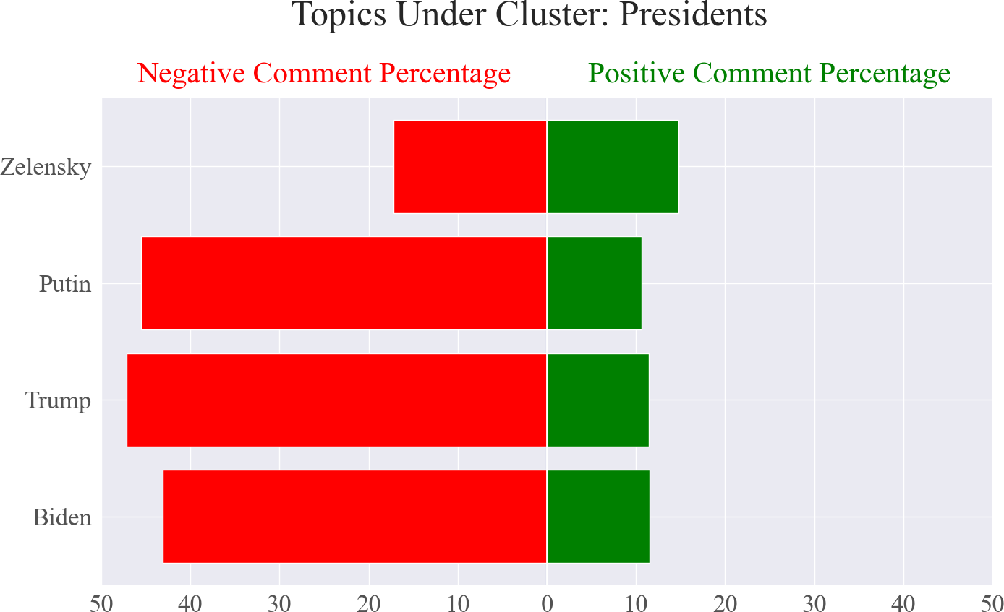

Figure A3: Sentiments detected in comments related to presidents of different countries

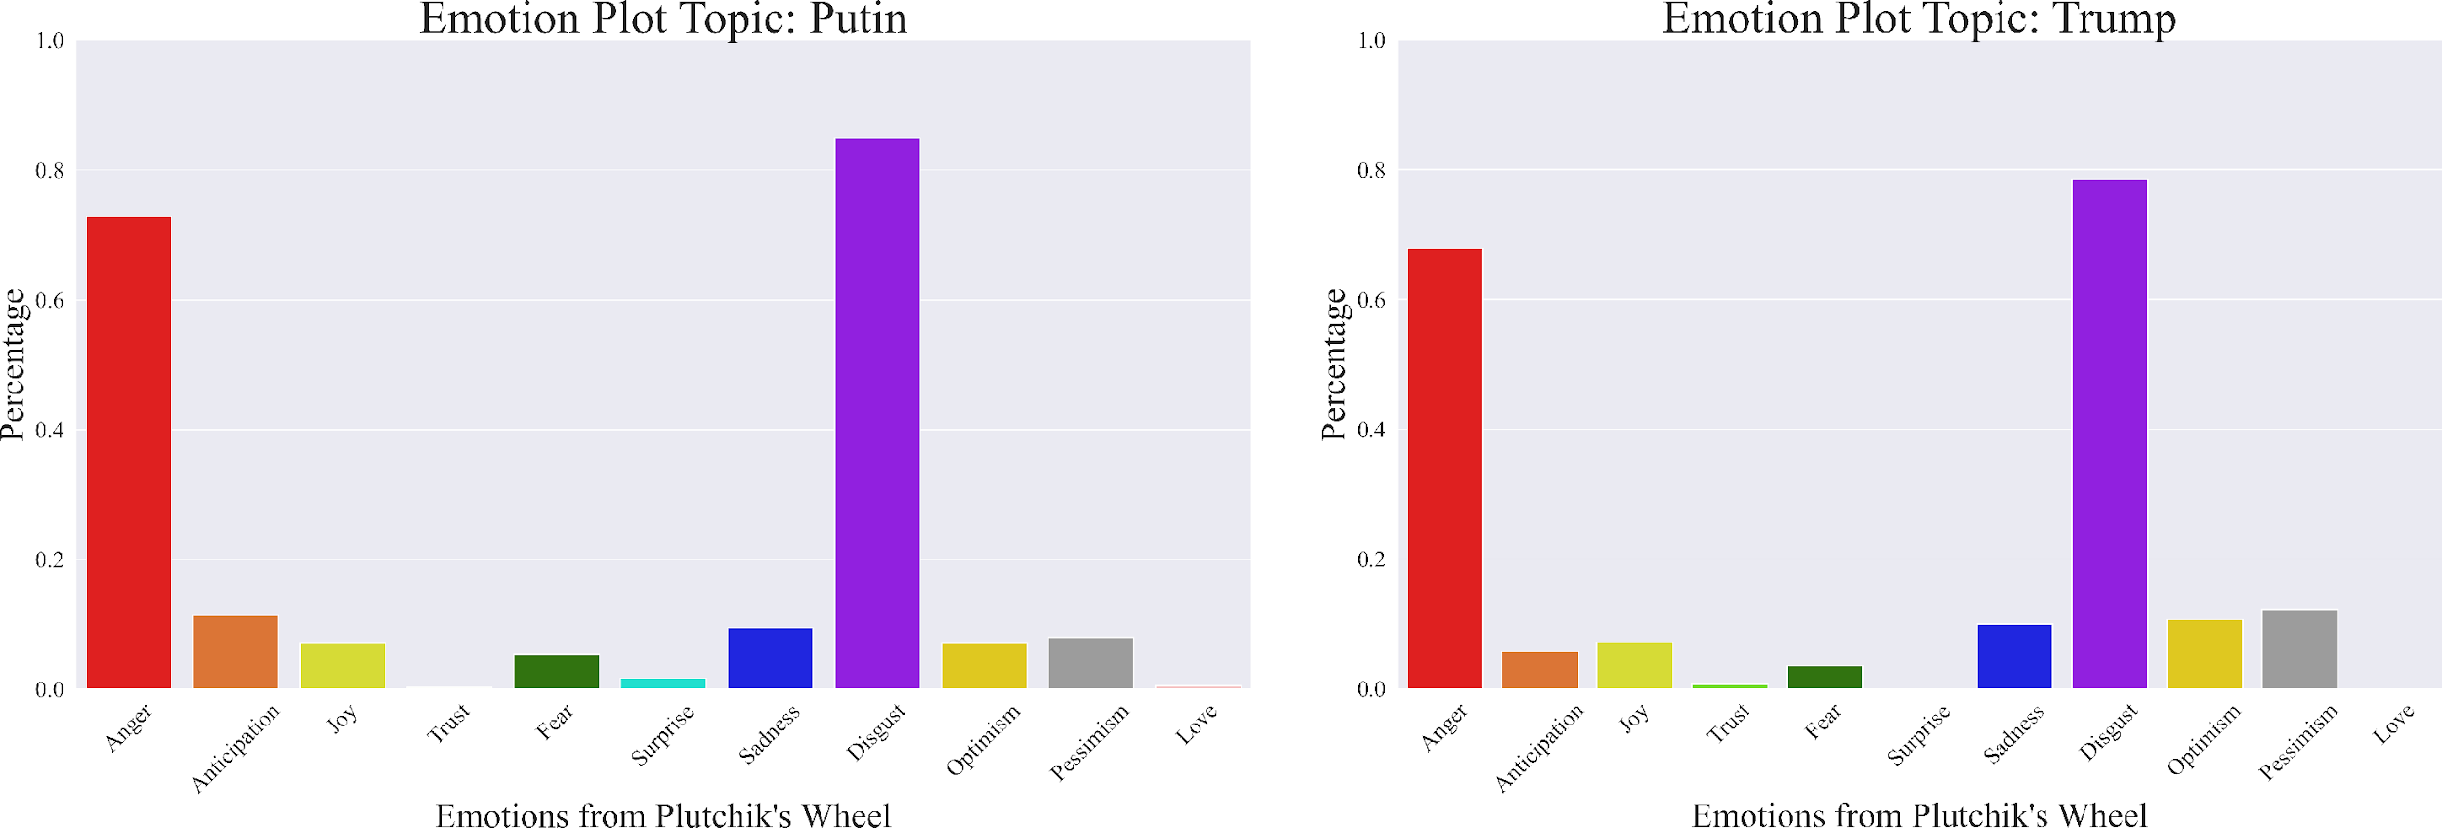

Figure A4: Emotions detected in comments related to Trump VS. Biden. Both are very disliked on Reddit. Comments regarding Putin demonstrate a significant higher percentage of the emotions of ”anger” and ”disgust”.

Figure A5 shows comparisons of sentiments identified for different firearms and weapons frequently mentioned in the Reddit comments. The sentiments reflect performance of each weapon system for example, the use of drones provided by Iran has resulted in numerous civilian casualties, causing a strong sense of resentment towards them. On the other hand, it appears that the majority of people believe that the US should provide Ukraine with air support that is better than the old and unwanted A-10 Warthogs.

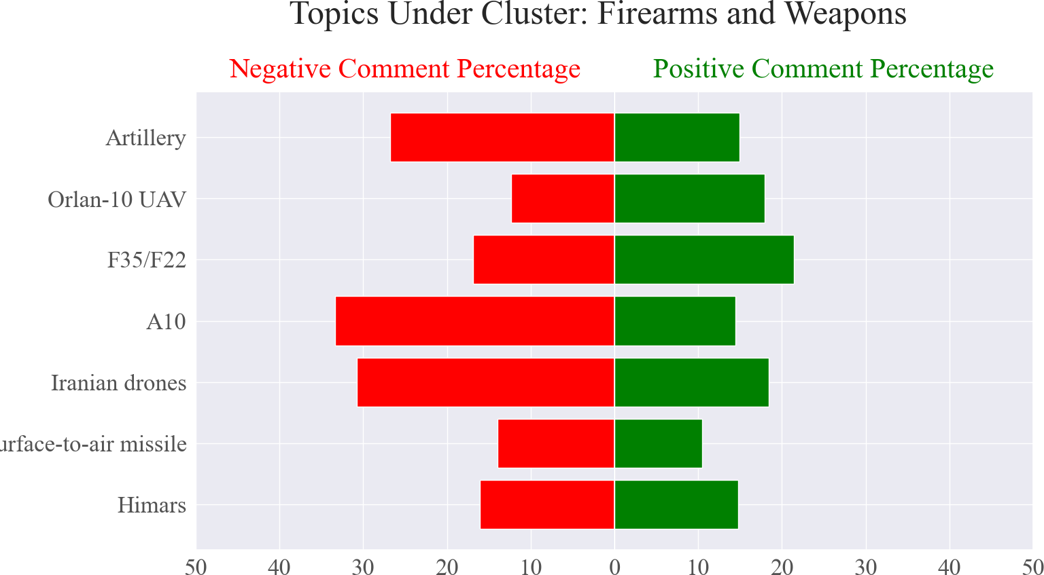

Figure A5: Sentiments detected in comments related to Firearms and Weapons frequently men- tioned in Reddit comments

Figure A6-11 shows sentiments regarding different comments identified. Figure A12 shows that comments regarding different countries and organizations. Most of them has a high distribution of negative sentiment.

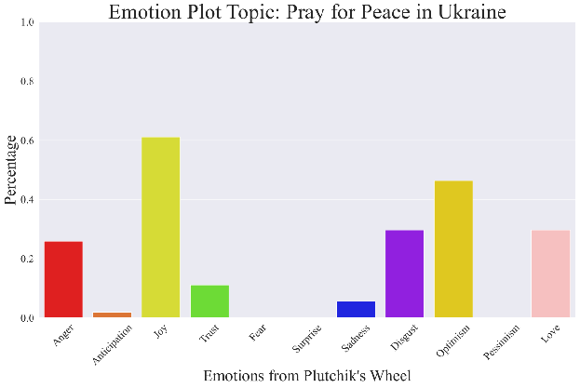

Figure A6: Emotions detected in comments related to Pray for Peace in Ukraine Comments demonstrate a

significant higher percentage of the emotions of ”joy” and ”optimism”.

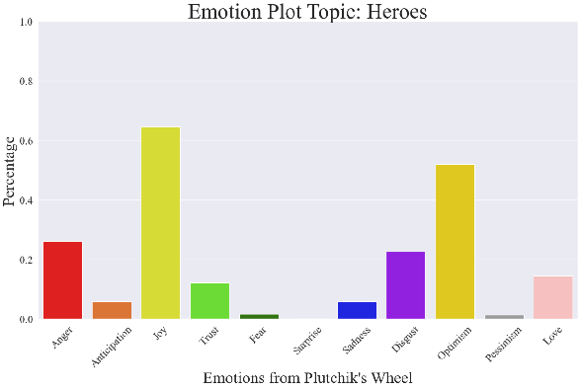

Figure A7: Emotions detected in comments related to Heroes. Comments demonstrate a significant higher percentage of the emotions of ”joy” and ”optimism”.

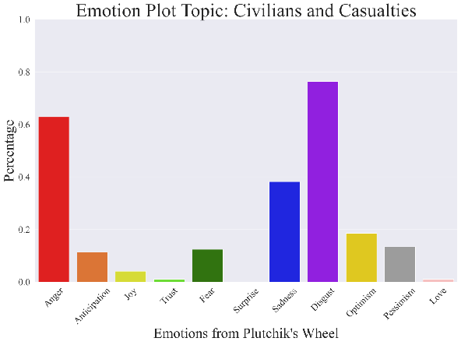

Figure A8: Emotions detected in comments related to Civilians and Casualties. Comments demonstrate a significant higher percentage of the emotions of ”anger” and ”disgust”.

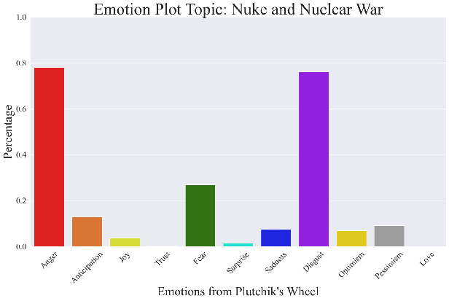

Figure A9: Emotions detected in comments related to Nuke and Nuclear War. Comments demonstrate a significant higher percentage of the emotions of ”anger” and ”disgust”.

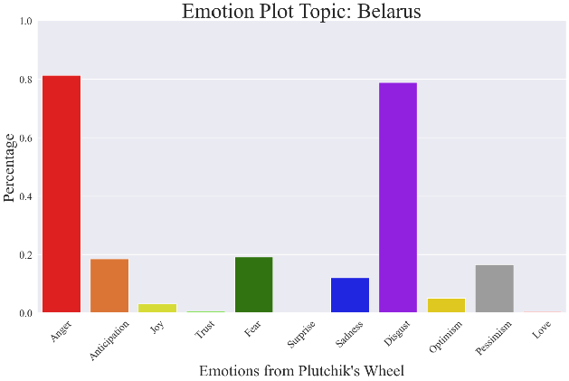

Figure A10: Emotions detected in comments related to Belarus. Comments demonstrate a significant higher percentage of the emotions of ”anger” and ”disgust”.

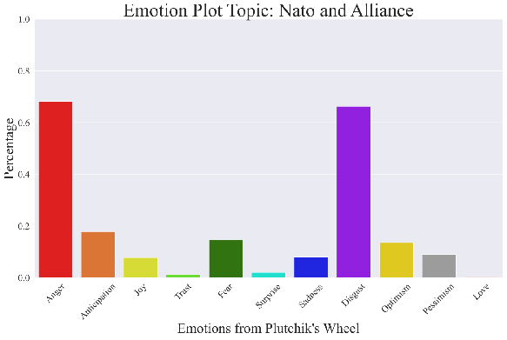

Figure A11: Emotions detected in comments related to NATO and Alliance. Comments demonstrate a significant higher percentage of the emotions of ”anger” and ”disgust”.

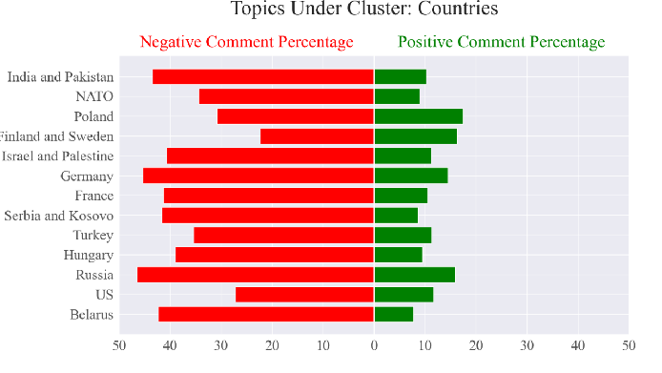

Figure A12: comparisons of sentiments identified for countries and organizations (under different topics).